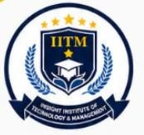
Satpura Education Society’s

Insight Institute of Technology and Management (IITM), Nagpur
Approved by AICTE New Delhi and DTE Mumbai Govt. of Maharashtra Affiliated to Rashtrasant Tukadoji Maharaj Nagpur University

Assignment 1
Subject: Data Communication & Network

- What is transmission media? Explain various types of media used for data transmission.
- Explain the OSI reference model with a diagram.
- Explain Digital Transmission in detail.

